[1]

Two-dimensional encoded multiplexing readout for THGEM

Guangyuan Yuan, Shubin Liu, Binxiang Qi, Changqing Feng, Siyuan Ma

*Abstract*—Micro-pattern Gas Detectors (MPGDs) have a wide application in high-energy physics, astrophysics, nuclear physics, medical imaging and so on. The demand of large area and good spatial resolution requires a large number of channels. The conventional two-dimensional tracking for MPGDs requires a large number of electronic channels, and in consequence poses a big challenge for the integration, power consumption, cooling and cost, which has become a problem to the further applications of MPGDs. In this paper, a new tracking method for MPGDs based on two-dimensional encoded multiplexing readout is present, which is easily-extensible and can significantly reduce the number of electronic readout channels.

*Index Terms*—micro-pattern gas detector, multiplexing readout, two-dimensional tracking

# INTRODUCTION

M

icro-pattern Gas Detectors (MPGDs) such as the Gas Electron Multiplier(GEM) [1], the Thick GEM(THGEM) [2] and the Micromegas [3], are widely used in particle physics. Owing to good spatial resolution, high rate capability, large active area and radiation hardness, MPGDs also play an important role in high-energy, astrophysics and medical imaging [4] [5]. To obtain good spatial resolution, the strip size should be reduced and a large effective area requires a large number of channels. The conventional readout techniques [6], usually strips readout, employ a large number of electronic channels. For example, in COMPASS, 5184 readout channels are needed for Micromegas and GEM [7]; in ATLAS NSW muon system upgrade, 2 million readout channels are needed for 1200 m2 Micromegas [8]. The large number of electronic channels results in a big challenge for the integration, power consumption, cooling and cost.

An encoded multiplexing readout technique was developed by S.Procureur et.al at Saclay, France [9], which can dramatically reduce the number of electronic readout channels. In our previous work, an easily-extensible encoding principle was presented [10]. In this paper, we extend our work to two-dimensional readout. Verification tests were carried out on a 5×5 cm2 Thick Gas Electron Multiplier (THGEM) [5]. In the verification test, 26 electronic channels are used to read out 100 strips (50 strips on X direction and 50 strips on Y direction), and 30 electronic channels are used to read out 200 strips (100 strips on X direction and 100 strips on Y direction). Up to 2× strips can be read out by 2k readout channels (k is odd).

# PRINCIPLE AND METHOD

## Encoding Principle

In our previous work, an easily-extensible one-dimensional encoded multiplexing readout for micro-pattern gas detectors is presented [10]. By using the redundancy that each particle usually showers the signal on several neighboring strips in MPGDs, a feasible and easily-extensible way of encoding and decoding has been developed for MPGD, and a general formula of encoding and decoding for *n* channels is derived.

TABLE I

The encoding list of multiplexing connections

|  |  |  |
| --- | --- | --- |
| row | list of encoded multiplexing connections | |
| 1 | 11, 22, 33 |
| 2 | 14, 45, 26, 57, 38, 49, 510 |
| 3 | 111, 612, 213, 714, 315, 616, 417, 718, 519, 620,721 |
| . | .................................. |
| *k* | 1+1, (*2k*)+2, 2+3, (*2k+1*)+4, 3+5, (*2k*)+6…..(*2k-1*)-2, (*2k*)-1, (*2k+1*) |
|  | 1 |

The encoded connections list by row. Add a new row on the list when two new channels are added.



Fig. 1. Encoding list of channels and strips. The form XY represents each multiplexing connection, where X is the electronic channel number and Y is the strip number along the detector.

The encoding list is shown in Table I. A row shows when readout channels are added from 2k+1 to 2k+3, up to 4k+3 more strips can be encoded. Fig. 1 shows the encoding list for 2k+1 readout channels, corresponding with strips. This method of encoded multiplexing readout can be easily extended to large number of readout channels.

(1)

(2)

Formula (1) shows the encoding rule. Readout channels (a,b) are connected with neighbor hit strips i and i+1.

.k is the Minimal positive integer meeting formula .

Formula (2) shows the decoding rules when 2 channels are fired. While channel a and channel b are fired, strip i and i+1 can be uniquely decoded.

Situation when more than 2 channels are fired are also discussed in our previous work. As is shown in Table I and Fig. 1, when 3 channels are fired, such as channel 2,3,5, the position can be uniquely decoded to strip 6,7,8. Details are described in reference [10].

## Two-Dimensional Tracking

 

Fig. 2. Two-dimensional readout construction. Readout anode structure as pads and strips is shown on the left, while structure as pads is shown on the right.

In two-dimensional tracking situation, this encoding method can be easily extended. We make a further step on our research and a two-dimensional readout is presented. Using two-dimensional orthogonal strips readout as charge collection electrode, encoding horizontal strips and vertical strips respectively, reading out the signals and decoding to get the hit strips, then synthesizing the results we implement two-dimensional readout. Fig. 2 shows two different electrode constructions for two-dimensional readout anode.

In order to verify our method, two types of encoded multiplexing anode readout PCB are manufactured with different anode structure and different number of readout strips. Several anode strips are connected to one electronic readout channel by encoding principle on the PCB.

### *Anode Structure as Pads*

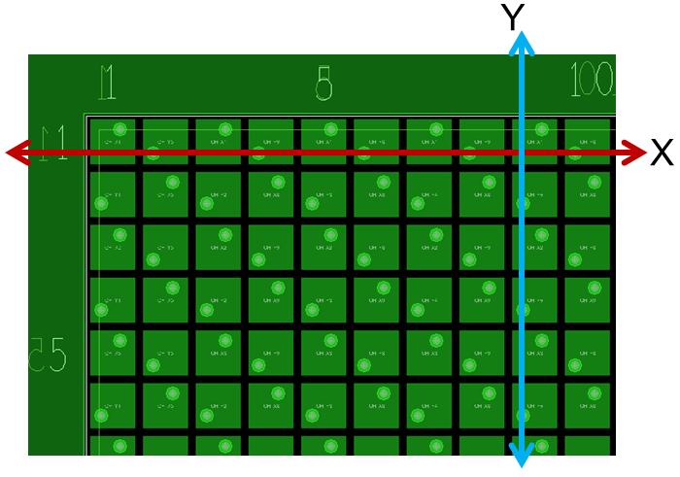

Fig. 3. Readout electrode as pads. A 5 × 5 cm2 active area is divided into 50×50 pads (1 × 1 mm2 each).

TABLE II

Encoding list of 50 readout strips

|  |  |  |
| --- | --- | --- |
| row | the list of encoded multiplexing connections | |
| 4 | 11,82,23,94,35,86,47,98,59,810,611,912,713,814,915 |
| 5 | 116, 1017, 218, 1119, 320, 1021, 422, 1123, 524, 1025, 626, 1127, 728, 1029, 830, 1131, 932, 1033, 1134 |
| 6 | 135, 1236, 237, 1338, 339, 1240, 441, 1342 ,543,1244, 645, 1346, 747, 1248, 849, 1350 |

Anode structure as pads is applied in the design of 50 × 50 readout PCB, as shown in Fig. 3. On each direction, 13 electronic channels are used to read out 50 strips, 26 electronic channels are used to read out all the 2500 pads. The connection of strips and readout channels are shown on Table II.

### Anode Structure as Pads and Strips

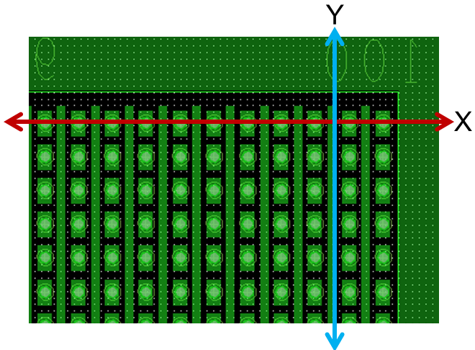

Fig. 4. Readout electrode as pads and strips. In a 5 × 5 cm2 active area, anodes on Y direction are designed in strips while strips on X direction are designed in pads, with equivalent pad area of 0.5 × 0.5 mm2.

TABLE III

Encoding list of 100 readout strips

|  |  |  |
| --- | --- | --- |
| row | list of encoded multiplexing connections | |
| 2 | 11,42,23,54,35,46,57 |
| 3 | 18,69,210,711,312,613,414,715,516,617,718 |
| 4 | 119,820,221,922,323,824,425,926,527,828,629,930,731,832,933 |
| 5 | 134, 1035, 236, 1137, 338, 1039, 440, 1141, 542, 1043, 644, 1145, 746, 1047, 848, 1149, 950, 1051, 1152 |
| 6 | 153, 1254, 255, 1356, 357, 1258, 459,..…….,765, 1266, 867, 1368,969,1270, 1071, 1372, 1173, 1274, 1375 |
| 7 | 176, 1477, 278, 1579, 380, 1481 ,482,1583.…………….….…..…,1094,1595, 1196, 1497, 1298, 1599, 13100 |

As to improve spatial resolution, we apply a new structure of readout anode in the design of 100 × 100 readout PCB. 15 electronic channels are used to read out 100 strips on each direction. 10,000 equivalent pads are read out by 30 electronic channels. The encoded multiplexing connection list are shown in Table III.

# Verification test

## Test Platform



Fig. 5. Test Platform Structure. An 8 keV Cu X-ray beam passes through Cu board engraved with letters to detector. Then read out signals selected by encoded anode PCB.

In order to verify this method, X-ray imaging verification tests were carried out on a 5 cm × 5 cm THGEM detector using Ar/iC4H10 (97:3) gas mixture. It has a hole-diameter of d=200 um, spaced by a=500 um. The thickness is t=200 um. The detector was biased to a total gain of gain of 1 × 104. The output signal of THGEM detector is about 5 fC ~ 100 fC, with system noise better than 2 fC. A 100 μm wide slit in a thin brass sheet was used to produce a miniaturized X-ray beam. A manual movable platform was used for the position scanning test. The test platform structure is shown in Fig. 5. Two different type of readout anode PCB are designed to collect the signals of detector, one with 1 mm wide pitch and another one with 0.5 mm wide pitch. Finally by decoding the channels’ signals we get the hit position and rebuild the pictures, thus two-dimensional imaging is implemented.

## Test Result

We apply electronics based on the VATA160 chip to read out the signals, which can offer charge quantity on each channel [11]. When decoding to get the hit position, we apply charge gravity method to improve spatial resolution. is the quantity of electric charge on readout strip I, and is the baseline of electronics.

(3)

In this method, the number of fired channels is important in decoding to get the hit position. Besides, spatial resolution and imaging result is used to measure the feasibility of this method.

### *50 × 50 Readout Result*

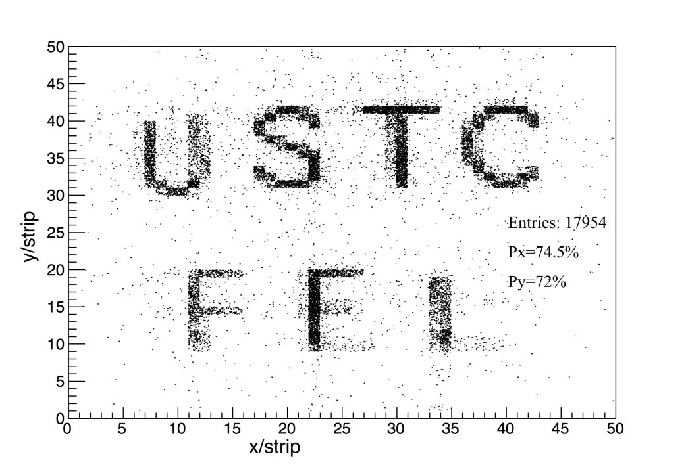

Fig. 6. Imaging result of 50×50 readout anode PCB.

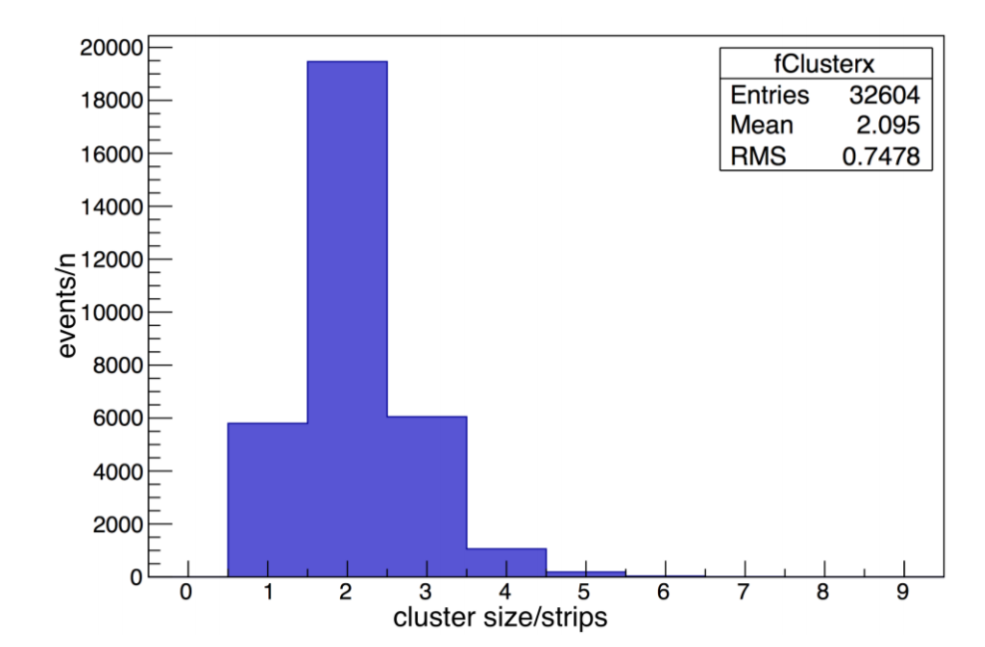

Fig. 7. Cluster size distribution on X direction, result of 50 × 50 readout electrode as pads, 1 × 1 mm2 each, equivalent 1 mm pitch.

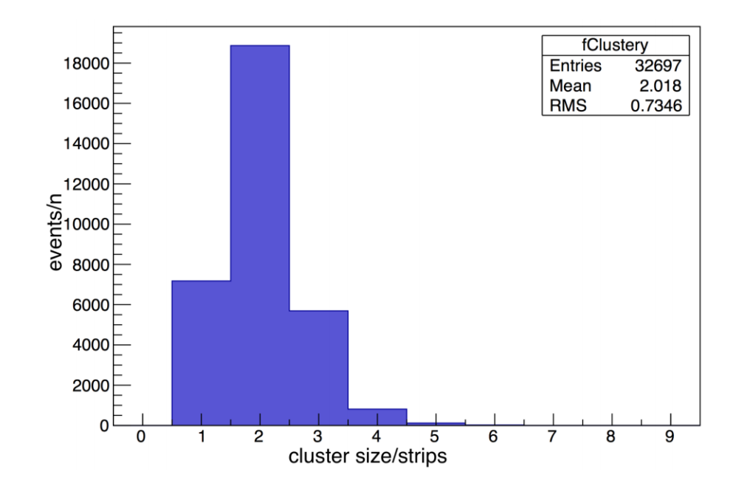

Fig. 8. Cluster size distribution on X direction, result of 50 × 50 readout electrode as pads, 1 × 1 mm2 each, equivalent 1 mm pitch.

Fig. 6 is the rebuilt image of 50 × 50 anode readout PCB. The threshold of electronics is set to 20 fC, 3 times of the baseline noise (7 fC). On X direction, about 19% of events hit only have 1 channel fired and can’t be decoded. On Y direction the rate is about 20%. When 2 channels records signals, such as channels 3,5, we can uniquely decode the position to strip 4,5 by Table III; when 3 channels records signals, such as 3,4,6, we can uniquely decode the position to strip 12,13,14. On the other side, when 4 strips are fired, such as 1,2,3,4, then channel 1,2,4,5 will record signals, we can uniquely decode the position to strip 1,2,3,4.

Position RMS on X direction is 0.7478 strip (0.7478 mm), and that on Y direction is 0.7346 strip (0.7346 mm). Fig. 7 and Fig. 8 show the cluster size distribution on X and Y direction.

### *100 × 100 Readout Result*

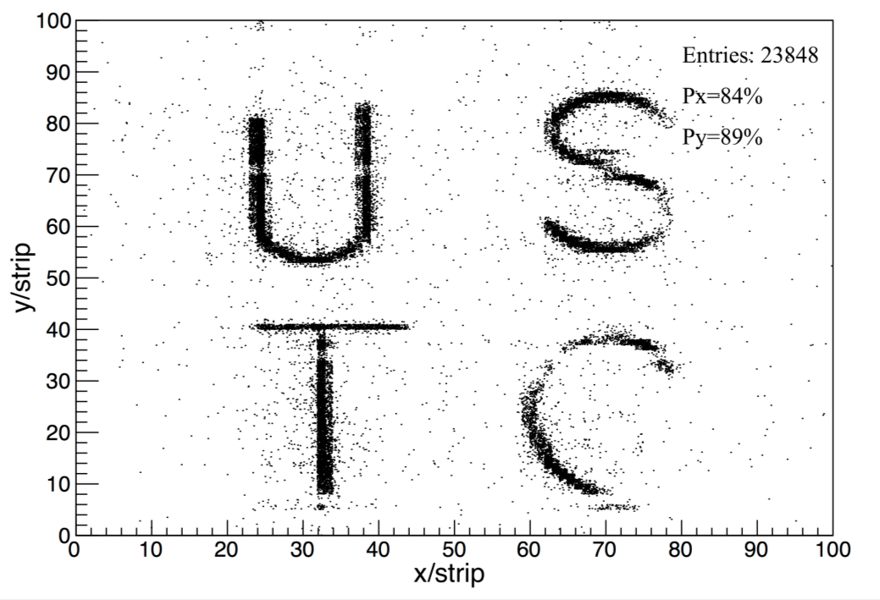

Fig. 9. Imaging result of 100×100 readout anode PCB.

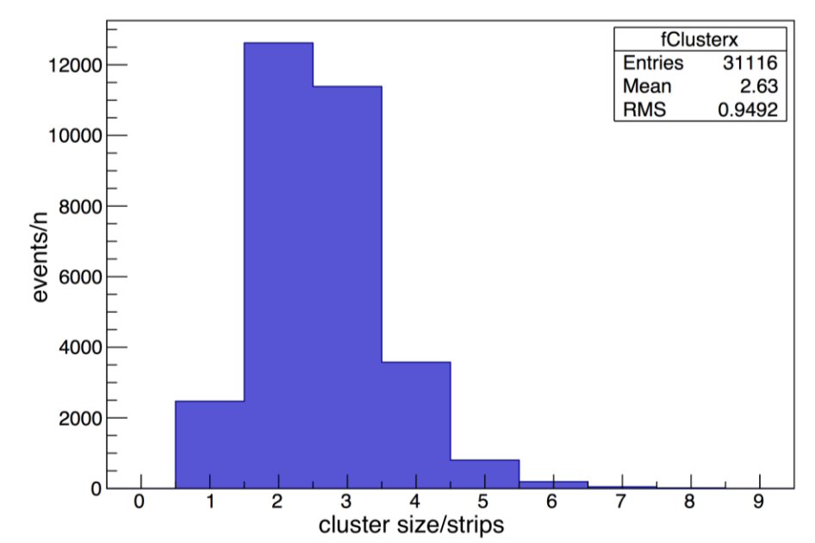

Fig. 10. Cluster size distribution on X direction, result of 100 × 100 readout electrode as pads, equivalent 0.5 mm pitch.

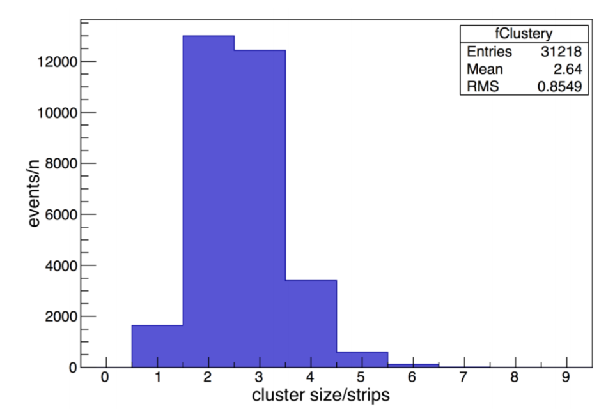

Fig. 11. Cluster size distribution on Y direction, result of 100 × 100 readout electrode as strips on Y direction, 0.5 mm pitch.

Fig. 9 is the rebuilt image of 100 × 100 anode readout PCB. The threshold of electronics is set to 20 fC, 3 times of the baseline noise. On X direction, about 7% of events hit only have 1 channel fired and can’t be decoded. On Y direction the rate is about 6%.

Position RMS on X direction is 0.95 strip (0.475 mm), and on Y direction is 0.85 strip (0.425 mm). The result shows that encoded multiplexing readout method is feasible for two-dimensional tracking. Lower-noise electronics are indispensable if we want clearer image.

# Conclusion

The test results show this method has a good performance in two-dimensional imaging for THGEM and can be easily extended to large number of readout strips. But there are still some place to be improved. As can be seen from the result of the two tests, smaller readout pads will help to get better spatial resolution and reduce the rate that some events can’t be decoded. Besides, the image rebuilt are not clear enough. We need electronics with lower noise to get clearer image.

As this two-dimensional readout method can dramatically reduce the number of readout channels, it has an attractive potential to help build MPGDs with large number of readout strips. What’s more, it can also have a wide range of position imaging applications such as medical imaging and industry.

References

1. Sauli F, “GEM: A new concept for electron amplification in gas detectors,” *Nuclear Instruments and Methods in Physics Research Section A*, vol. 386, pp. 531-534, Feb. 1997.
2. Breskin A et al., “A concise review on THGEM detectors,” *Nuclear Instruments and Methods in Physics Research Section A*, vol. 598, pp. 107-111, Jan. 2009.
3. Giomataris Y et al., “MICROMEGAS: a high-granularity position-sensitive gaseous detector for high particle-flux environments,” *Nuclear Instruments and Methods in Physics Research Section A*, vol. 376, pp.29-35, Jun. 1996.
4. Titov M, “New developments and future perspectives of gaseous detectors,” *Nuclear Instruments and Methods in Physics Research Section A*, vol. 581, pp.25-37, Oct. 2007.
5. Liu Q et al., “A successful application of thinner-THGEMs,” in *Proc*. *3rd international conference on micro pattern gaseous detectors*, Zaragoza, Spain, Jul. 2013.
6. Bressan A et al., “Two-dimensional readout of GEM detectors,” *Nuclear Instruments and Methods in Physics Research Section A*, vol. 425, pp.254-261, Apr. 1999.
7. Abbon P et al., “The COMPASS experiment at CERN,” *Nuclear Instruments and Methods in Physics Research Section A*, vol. 577, pp. 455-518, Jul. 2007.
8. Iakovidis G, “The Micromegas project for the ATLAS upgrade,” in *Proc*. *3rd international conference on micro pattern gaseous detectors*, Zaragoza, Spain, Jul. 2013.
9. Procureur S et al., “Genetic multiplexing and first results with a 50× 50cm 2 Micromegas,” *Nuclear Instruments and Methods in Physics Research Section A*, vol. 729, pp.888-894, Nov. 2013.
10. Qi B X et al., “A Novel Method of Encoded Multiplexing Readout for Micro-pattern Gas Detectors,” *Chinese Physics C,* vol. 40, no. 5, pp. 58-62, May, 2016.
11. Feng C et al., “Design of the readout electronics for the BGO calorimeter of DAMPE mission,” *IEEE Transactions on Nuclear Science*, vol. 62, no. 6, pp. 3117-3125, Dec. 2015.

1. Manuscript received June 19, 2016; revised April 5, 2017.

   This work was supported by National Natural Science Foundation of China (Grant No.11222552).

   The authors are with State Key Laboratory of Particle Detection and Electronics, University of Science and Technology of China, No.96, Jinzhai Road, Hefei, Anhui, China (e-mail: liushb@ustc.edu.cn).